COMMON COURSE ASSIGNMENT
CSA04 – OPERATING SYSTEMS | Covering Process Scheduling, Memory Management & Disk Scheduling

BHAVYA LAKSHMI V

192421159

A. Assignment Information
Department | Computer Science and Engineering
Programme | B.E. / B.Tech – CSE
Course Code & Course Name | CSA04 – Operating Systems
Academic Year / Batch | 2026 – 2027
Faculty Name | Dr.Chandravathi
Assignment Title | Design and Implementation of OSLearn – An Interactive OS Algorithm Trainer using Streamlit
Date of Issue | 21/08/2026
Date of Submission | 02/09/2026
Maximum Marks | 100
Course Outcome(s) – CO | CO2, CO3, CO4
Bloom's Taxonomy Level | L3 – Apply, L4 – Analyze, L5 – Evaluate
SDG Mapping (SDG 1–17) | SDG 4 – Quality Education; SDG 9 – Industry, Innovation and Infrastructure
Industry / Societal Relevance | Interactive educational tools improve conceptual understanding of OS algorithms used in real-world servers, cloud platforms, and embedded systems, supporting quality technical education.

B. Assignment Problem / Challenge
This assignment requires students to design, implement, and evaluate an interactive Operating Systems simulator that applies core CSA04 concepts — process scheduling (Units I–II), memory management with paging and page replacement (Unit III), and disk scheduling (Unit IV) — to a unified educational training platform called OSLearn. Students must integrate multiple algorithm families, produce clear comparative visualizations and step-by-step traces, deploy the system as a lightweight web application using Streamlit, validate correctness and usability with sample test cases, and address basic responsible-computing considerations such as transparency of intermediate steps and reproducibility of results.

C. Problem Statement
Scenario: “OSLearn” – Interactive OS Algorithm Trainer
Many students find it difficult to understand how CPU scheduling, page replacement, and disk scheduling algorithms actually work just by reading theory. Your task is to design and implement an interactive educational web application called OSLearn that helps students practice, visualize, and compare these core Operating Systems algorithms through a unified interface.
The system shall integrate three major OS algorithm families:

1. Process Scheduling
Implement FCFS, SJF (Non-preemptive), and Round Robin.
- Users should be able to enter process details (Process ID, Arrival Time, Burst Time, and Time Quantum for Round Robin).
- The system must display a Gantt chart / timeline visualization together with a table showing Waiting Time, Turnaround Time, and Average Waiting/Turnaround Time for each algorithm, enabling side-by-side comparison.

2. Memory Management (Page Replacement)
Implement FIFO and LRU page-replacement algorithms.
- Users will enter the number of frames and a page reference string.
- The system should show the step-by-step frame status after each reference, highlight page faults, and report the total number of page faults for each algorithm so that students can compare performance.

3. Disk Scheduling
Implement FCFS, SSTF, and SCAN.
- Users will enter the disk request queue and the initial head position.
- The system should display the order of servicing (seek sequence) and the total seek time for each algorithm, allowing clear comparative analysis.
Design the application workflow so that user inputs (process lists, reference strings, disk request queues) are processed by the corresponding algorithms and the results are presented as clear tables, Gantt charts, step-by-step traces, and comparative metrics. Develop a clean, simple web interface using Streamlit. Provide 2–3 sample test cases for each module to demonstrate correctness. Optionally, students may add brief natural-language explanations of algorithm steps (no external LLM required).
Evaluate the application under suitable test cases and analyze correctness of algorithm results, usability of the interface, and clarity of visualizations. The completed system should also briefly address responsible-computing considerations including transparency of intermediate simulation steps, reproducibility of results, and educational ethics in presenting algorithm behavior.

D. Requirements and Constraints
- Functional: Provide interactive modules for Process Scheduling (with Gantt charts and timing metrics), Memory Management / Page Replacement (with frame-status traces and page-fault counts), and Disk Scheduling (with seek sequences and total seek times). Accept user inputs as well as sample data. Produce comparative tables, charts, and step-by-step traces.
- Interface: Clean, simple, and user-friendly Streamlit web application with separate pages or clearly separated sections for each module.
- Performance: Simulations must produce correct results with acceptable latency for interactive classroom use and support clear comparative analysis across algorithms.
- Technical constraint: Use Python + Streamlit. No database, no complex architecture, and no mandatory external LLM integration. Open-source tools only.
- Reliability: Algorithm implementations must be correct and reproducible; intermediate steps must be transparent; the system must handle common edge cases without crashing.
- Resource constraint: Project must be completable within the semester timeline using standard student computing resources.
- Responsible Computing: Ensure transparency of simulation steps, reproducibility of results, avoidance of misleading default parameters, and adherence to educational ethics.
- Evaluation & Submission: Test all three modules with sample inputs and show correct results. Submit working Streamlit code, a short report containing sample outputs / screenshots, comparative analysis, and a GitHub repository link.

E.Student Work

CAMPUSCONNECT – OPERATING SYSTEM RESOURCE MANAGEMENT DESIGN

- Problem Understanding and Formulation

1.1 Introduction
CampusConnect is a campus-oriented information-sharing system in which many students, faculty members and administrative users simultaneously access academic files and services. The system may contain text documents, assignments, notices, images, presentations, audio files and large video files.
Since many users can access the system concurrently, the Operating System must efficiently manage:
- Processes and threads
- Shared-file access
- Memory and virtual memory
- File allocation
- Disk I/O
- Deadlocks and resource allocation
The proposed design applies concepts from Process Management, Memory Management and File Systems, which are the major areas covered in Units II–IV of the CSA04 syllabus. The syllabus specifically identifies process synchronization, semaphores, monitors, deadlocks and Banker’s Algorithm in Unit II; paging, virtual memory, demand paging, page replacement and working sets in Unit III; and file allocation, Unix file systems, buffer cache, inodes and disk scheduling in Unit IV.

1.2 Synchronization Challenges
CampusConnect has multiple users accessing the same academic files.
For example:
- Several students may read a lecture note simultaneously.
- A faculty member may update the same file while students are reading it.
- Multiple processes may request the same printer or network resource.
- Concurrent updates can result in inconsistent file contents.
Therefore, synchronization is required to prevent race conditions.
The classical Readers–Writers problem is appropriate because:
- Multiple readers can safely read simultaneously.
- A writer requires exclusive access.
- A reader must not read partially updated data.

1.3 Memory Challenges
If 300 users are simultaneously active, each session requires memory for:
- Program instructions
- Data
- Buffers
- File-related information
- User interface/application components
Physical RAM is limited. Therefore, CampusConnect requires:
- Paging
- Demand paging
- Page replacement
- Working-set management
Poor memory allocation can cause thrashing, where the system spends more time transferring pages than executing processes.

1.4 File-System Challenges
CampusConnect has a mixed workload:

File Type | Typical Size
Text/notes | KB–MB
Assignments | MB
Presentations | MB–100 MB
Images | MB
Audio | 10–100 MB
Videos | 100 MB–several GB
A single allocation technique is therefore not equally efficient for every file.

1.5 Expected Outcomes
The proposed system should provide:
- Deadlock-free or controlled resource allocation
- Race-free shared-file access
- Efficient memory utilization
- Reduced page faults
- Reduced thrashing
- Fast disk access
- Fair access among users
- Reliable academic-file storage
- Good scalability for approximately 300 concurrent sessions

1.6 Assumptions
For the analysis, the following assumptions are made:

Parameter | Assumption | Justification
Concurrent sessions | 300 | Represents a busy campus environment
Physical memory | 8 GB | Given in the problem
Page size | 4 KB | Given in the problem
Representative process address space | 64 MB | Given in the problem
Number of resource types | 4 | Given in the problem
Processes for Banker analysis | 4 | Given in the problem
Disk cylinders | 200 | Given in the problem
Disk requests | 8 | Minimum required
Page-replacement frames | 3 | Convenient for comparison
File workload | Mixed | Represents campus files

2. Application of Course Knowledge

PART I – PROCESS SYNCHRONIZATION AND DEADLOCK

4. Readers–Writers Synchronization
The shared-file problem can be modeled as the Readers–Writers synchronization problem.
The objective is:
- Multiple readers may read simultaneously.
- Only one writer may write at a time.
- Readers cannot access the file while a writer is modifying it.
Semaphores
semaphore mutex = 1
semaphore writeLock = 1

integer readCount = 0
Reader
READER(
BEGIN
wait(mutex)
readCount = readCount + 1
IF readCount == 1 THEN
wait(writeLock)
ENDIF
signal(mutex)
READ shared_file
wait(mutex)
readCount = readCount - 1
IF readCount == 0 THEN
signal(writeLock)
ENDIF
signal(mutex)
END
Writer
WRITER()
BEGIN
wait(writeLock)
WRITE shared_file
signal(writeLock)
END

Explanation
mutex protects the readCount variable.
writeLock ensures that only one writer accesses the file at a time.
When the first reader enters, it locks writeLock.
When the last reader leaves, it releases writeLock.
Therefore:
- Readers can execute concurrently.
- Writers obtain exclusive access.
- Race conditions are prevented.
This directly applies the syllabus topics critical-section problem, semaphores and classical synchronization problems.

5. Banker’s Algorithm
Consider four processes:
P1, P2, P3, P4
and four resources:
- R1 = Database Handle
- R2 = Print Spooler
- R3 = Network Socket
- R4 = File Lock

Allocation Matrix
Process | R1 | R2 | R3 | R4
P1 | 1 | 0 | 1 | 0
P2 | 1 | 1 | 0 | 1
P3 | 1 | 0 | 1 | 1
P4 | 0 | 1 | 0 | 0

Maximum Matrix
Process | R1 | R2 | R3 | R4
P1 | 2 | 1 | 1 | 1
P2 | 1 | 2 | 1 | 1
P3 | 2 | 1 | 2 | 1
P4 | 1 | 1 | 1 | 1

Available
Assume:
Available = (1, 1, 1, 1)
Need Matrix
Formula:
Need = Maximum − Allocation
Therefore:
Process | R1 | R2 | R3 | R4
P1 | 1 | 1 | 0 | 1
P2 | 0 | 1 | 1 | 0
P3 | 1 | 1 | 1 | 0
P4 | 1 | 0 | 1 | 1

Safety Algorithm
Initially:
Work = (1,1,1,1)
Step 1 – P1
Need(P1):
(1,1,0,1)
Since:
(1,1,0,1) ≤ (1,1,1,1)
P1 can finish.
After P1 releases its allocation:
Work = (2,1,2,1)

Step 2 – P2
Need(P2):
(0,1,1,0)
This is less than Work.
After P2 finishes:
Work = (3,2,2,2)

Step 3 – P3
Need(P3):
(1,1,1,0)
P3 can finish.
Work = (4,2,3,3)

Step 4 – P4
Need(P4):
(1,0,1,1)
P4 can finish.
Therefore:
Safe Sequence
P1 → P2 → P3 → P4
Result
The system is in a SAFE STATE.
The Banker’s Algorithm is explicitly included in the CSA04 Unit II syllabus.

6. Deadlock-Handling Strategy
The four major approaches are:
- Deadlock Prevention
- Deadlock Avoidance
- Deadlock Detection
- Deadlock Recovery
Recommended strategy: Deadlock Avoidance
For CampusConnect, Deadlock Avoidance using Banker’s Algorithm is recommended for critical shared resources.
Reasons
CampusConnect has resources such as:
- Database handles
- File locks
- Network sockets
- Printing resources
Incorrect allocation can block important campus services.
Banker’s Algorithm checks whether granting a request keeps the system in a safe state.

Comparison
Strategy | Advantage | Disadvantage
Prevention | Simple concept | Restricts resource utilization
Avoidance | Avoids unsafe states | Requires maximum-resource information
Detection | Flexible | Deadlock may occur
Recovery | Can restore system | Recovery can cause data loss/disruption

Thus, avoidance is suitable for predictable critical resources, while time-sensitive noncritical resources can use timeout/retry mechanisms.
PART II – MEMORY MANAGEMENT
7. Paging Calculation
Given:
Physical memory = 8 GB
Page size = 4 KB
Using:
1 GB = 1024 MB
1 MB = 1024 KB
Therefore:
8 GB = 8 × 1024 × 1024 KB
= 8,388,608 KB
Number of frames:
Number of frames
= Physical memory / Frame size

= 8,388,608 / 4

= 2,097,152 frames
Answer
Number of physical frames = 2,097,152

Logical Address Space
Given:
Logical address space = 64 MB
Page size = 4 KB
64 MB = 64 × 1024 KB
= 65,536 KB
Therefore:
Pages = 65,536 / 4
= 16,384 pages
Answer
Number of pages = 16,384

Page Number and Offset
Since:
4 KB = 4096 bytes = 2¹²
Offset requires:
12 bits
Number of pages:
16,384 = 2¹⁴
Therefore page number requires:
14 bits
Total logical address:
14 + 12 = 26 bits
Address Format
| Page Number | Page Offset |
|-------------|-------------|
| 14 bits | 12 bits |

Page Table
The page table contains 16,384 entries.
Each entry can contain:
- Frame number
- Valid/invalid bit
- Protection bits
- Reference bit
- Dirty bit
A hierarchical page table can be used to reduce page-table memory overhead.
Paging and virtual-memory techniques are explicitly covered under Unit III.

8. Page Replacement Comparison
Consider the reference string:
1 2 3 4 1 2 5 1 2 3 4 5 2 1
Number of frames:
3
Algorithms:
- FIFO
- LRU
- Optimal
Results
Algorithm | Page Faults | Hits
FIFO | 10 | 4
LRU | 9 | 5
Optimal | 7 | 7

Interpretation
FIFO is simple but may remove a page that is still frequently used.
LRU considers recent access history and generally performs better when programs demonstrate locality.
Optimal produces the minimum possible number of page faults because it replaces the page whose next use is farthest in the future.
However, Optimal cannot be directly implemented in a real system because future references are unknown.
Recommended Algorithm
LRU or an LRU approximation is recommended for CampusConnect because user sessions usually demonstrate temporal locality.
Page replacement, virtual memory, demand paging and thrashing are explicitly included in Unit III.

9. Demand Paging and Working Set
With 300 concurrent sessions, loading every page of every application into RAM would waste physical memory.
Demand Paging
With demand paging:
- Only required pages are loaded.
- Unused pages remain on secondary storage.
- A page fault occurs when a required page is absent.
- The OS loads the required page.
- Execution continues.

Working Set
The working set is the collection of pages actively used by a process during a particular time interval.
For CampusConnect, assume:
Average working set = 8–16 pages/session
For 300 sessions:
300 × 8 = 2,400 pages
to
300 × 16 = 4,800 pages
would represent the approximate active working sets under this simplified model.
The OS should dynamically adjust frame allocation based on actual page-fault behavior.

Recommended Policy
Use:
Minimum allocation: 8 pages/session
Normal allocation: 12 pages/session
Maximum allocation: 16 pages/session
If page-fault frequency becomes high:
- Allocate additional frames to active sessions.
- Reduce frames assigned to inactive sessions.
- Suspend or swap low-priority inactive sessions if necessary.
This reduces the possibility of thrashing.

PART III – FILE SYSTEMS AND DISK SCHEDULING
10. File Allocation Methods
The syllabus includes contiguous, sequential and indexed allocation, along with Unix file-system concepts.
Comparison
Feature | Contiguous | Linked | Indexed
Sequential access | Excellent | Good | Good
Random access | Excellent | Poor | Excellent
Fragmentation | External fragmentation | Low | Low
File growth | Difficult | Easy | Easy
Large files | Less suitable | Suitable | Very suitable
Metadata overhead | Low | Pointer overhead | Index-block overhead

Recommended Approach
For CampusConnect, indexed allocation / inode-based allocation is the most suitable conceptual choice.
Reasons:
- Supports large files.
- Supports direct/random access.
- Files can grow without requiring a single contiguous disk region.
- Works naturally with Unix-style inode structures.
For very large video files, multi-level indexing can be used.

11. Disk Scheduling
Assume:
Disk cylinders = 0–199
Initial head = 50
Request queue:
82, 170, 43, 140, 24, 16, 190, 65

FCFS
Order:
50 → 82 → 170 → 43 → 140 → 24 → 16 → 190 → 65
Head movement:
|50-82| = 32
|82-170| = 88
|170-43| = 127
|43-140| = 97
|140-24| = 116
|24-16| = 8
|16-190| = 174
|190-65| = 125
Total:
32 + 88 + 127 + 97 + 116 + 8 + 174 + 125
= 767 cylinders

SCAN
Assume the head initially moves toward cylinder 199.
Requests greater than 50:
65, 82, 140, 170, 190
Requests below 50:
43, 24, 16
Order:
50 → 65 → 82 → 140 → 170 → 190 → 199
→ 43 → 24 → 16
Movement:
50 → 199 = 149
199 → 16 = 183
Total:
332 cylinders

C-SCAN
Assume movement is toward higher-numbered cylinders.
Order:
50 → 65 → 82 → 140 → 170 → 190 → 199
→ 0 → 16 → 24 → 43
Movement:
50 → 199 = 149
199 → 0 = 199
0 → 43 = 43
Total:
391 cylinders

Comparison
Algorithm | Total Head Movement
FCFS | 767
SCAN | 332
C-SCAN | 391

Best quantitative result
SCAN has the lowest head movement in this example.
Fairness
C-SCAN provides a more uniform waiting time because requests are serviced in one direction before the head returns to the beginning.
Therefore:
- SCAN → better movement
- C-SCAN → better uniformity/fairness
- FCFS → simplest but inefficient

12. Unix File-System Concepts
The syllabus specifically includes a case study of the Unix file system, including buffer cache and inodes, and system calls such as ialloc, ifree, namei, alloc and free.
Inodes
An inode stores file metadata such as:
- File type
- File size
- Ownership
- Permissions
- Timestamps
- Pointers to data blocks
CampusConnect can use inode-based structures to manage academic files.

Buffer Cache
Frequently accessed blocks can be retained in memory.
For example:
Student requests lecture.pdf
↓
Check buffer cache
↓
Cache hit?
↓ Yes ↓ No
Return data Read disk
↓
Store in cache
↓
Return data
This reduces unnecessary disk operations.

3. Consolidated Solution / Design Methodology
3.1 Overall Architecture
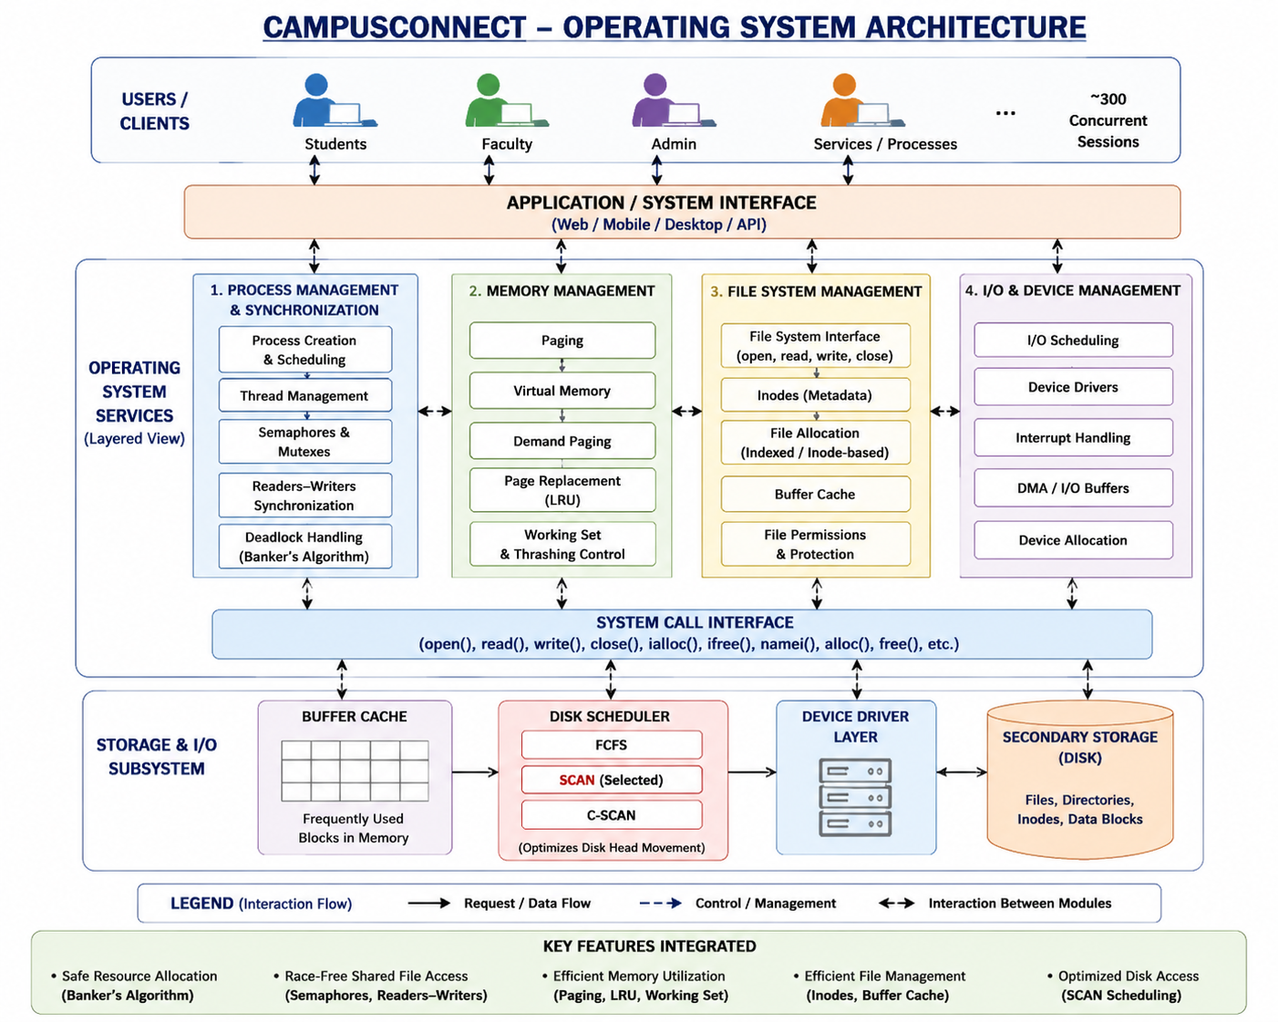

3.2 Synchronization Design
Selected mechanisms
Readers-Writers
+
Semaphores
+
Deadlock Avoidance
+
Banker's Algorithm
Critical shared resources are protected using semaphores.

3.3 Memory Design
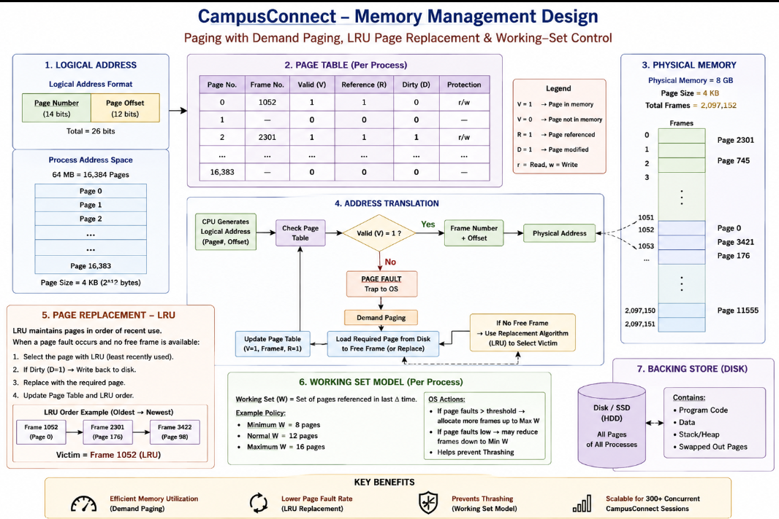

Working-set monitoring prevents excessive page faults.

3.4 File-System Design
Recommended:
Unix-style inode/index-based allocation
+
Buffer Cache
+
SCAN disk scheduling
This combination supports:
- Large files
- Random access
- Efficient metadata management
- Reduced disk movement
- Good throughput

4. Use of Modern Tools
The project can be implemented using:
Python
Python can simulate:
- Banker’s Algorithm
- FIFO
- LRU
- Optimal
- FCFS
- SCAN
- C-SCAN
C + Linux/WSL
C with POSIX threads can demonstrate:
pthread_create()
pthread_join()
sem_init()
sem_wait()
sem_post()
A Readers–Writers program can be executed with multiple reader and writer threads.

Suggested Evidence
Include screenshots showing:
- Python Banker output
- Page-replacement output
- Disk-scheduling output
- Linux semaphore program
- Multiple readers executing simultaneously
- Writer obtaining exclusive access
This satisfies the syllabus outcome concerning implementation of OS algorithms using software tools.

5. Results and Validation
5.1 Page Replacement
Algorithm | Page Faults | Performance
FIFO | 10 | Moderate
LRU | 9 | Good
Optimal | 7 | Theoretical best

Result
Optimal < LRU < FIFO
in terms of page faults for the selected reference string.

5.2 Disk Scheduling
Algorithm | Head Movement
FCFS | 767
SCAN | 332
C-SCAN | 391

Result
SCAN provides the lowest movement for the selected queue.

5.3 Banker’s Algorithm
Initial Work = (1,1,1,1)

P1 → Work = (2,1,2,1)
P2 → Work = (3,2,2,2)
P3 → Work = (4,2,3,3)
P4 → Work = (4,3,3,3)
Therefore:
SAFE SEQUENCE = P1 → P2 → P3 → P4

6. Analysis and Engineering Decision
6.1 Page Replacement
FIFO
Advantages:
- Simple
- Low implementation overhead
Disadvantage:
- Does not consider actual usage
LRU
Advantages:
- Uses recent-access information
- Works well with locality
Disadvantage:
- More overhead than FIFO
Optimal
Advantages:
- Minimum possible page faults
Disadvantage:
- Future references are unknown
Decision
LRU is selected for CampusConnect because user applications generally show locality of reference.

6.2 Disk Scheduling
Factor | FCFS | SCAN | C-SCAN
Simplicity | Excellent | Good | Good
Seek efficiency | Poor | Excellent | Very good
Fairness | Moderate | Good | Excellent
Starvation risk | Low | Low | Low
CampusConnect suitability | Moderate | High | High

Decision
SCAN is selected because it provides excellent seek efficiency while maintaining reasonable fairness.
C-SCAN can be considered when uniform waiting time is more important than minimum head movement.

6.3 Deadlock Strategy Trade-off
Prevention
Prevents deadlock by restricting resource allocation.
Problem: resource utilization may decrease.
Avoidance
Checks whether each allocation keeps the system safe.
Problem: requires additional computation and maximum-resource information.
Detection and Recovery
Allows allocation and detects deadlocks later.
Problem: recovery may interrupt users and potentially affect file operations.
Decision
Banker-based avoidance is preferable for critical predictable resources because reliability is more important than small allocation overhead.

7. Broader Considerations
7.1 Reliability and Safety
Data integrity is maintained using:
- Mutual exclusion for writers
- File locking
- Controlled concurrent access
- Buffer-cache consistency
- Permission checks
- Safe resource allocation
Only one writer should modify a shared academic file at a time.

7.2 Sustainability and Economics
Efficient OS resource management can reduce:
- Unnecessary disk operations
- Memory wastage
- CPU waiting
- Excessive storage requirements
- Hardware utilization
Buffer caching reduces repeated disk accesses.
Demand paging prevents unnecessary memory allocation.
Efficient disk scheduling reduces mechanical head movement for HDD-based systems.
Therefore, better OS design can contribute to lower energy consumption and hardware requirements.

7.3 Accessibility and Society
A fair resource-management system should ensure that one user does not monopolize:
- CPU resources
- Memory
- Disk
- File locks
- Network resources
SCAN provides relatively fair disk access, while synchronization mechanisms prevent indefinite blocking of users.

7.4 Ethics and Professional Responsibility
CampusConnect may handle:
- Student records
- Assignments
- Academic results
- Faculty materials
- Personal information
Therefore, the system should implement:
- Authentication
- Authorization
- File permissions
- Data confidentiality
- Secure storage
- Audit logging
- Controlled file sharing

8. Conclusion
The CampusConnect resource-management problem can be effectively addressed by integrating operating-system concepts from process management, memory management and file systems.
For synchronization, the Readers–Writers model with semaphores prevents race conditions during shared-file access.

Banker’s Algorithm demonstrates that safe resource allocation can be achieved with the safe sequence:
P1 → P2 → P3 → P4
For memory management, the 8 GB physical memory with 4 KB pages provides:
2,097,152 physical frames

while a 64 MB process requires:
16,384 pages
For page replacement, LRU provides a practical compromise between simple FIFO and theoretical Optimal replacement.
For file management, indexed/inode-based allocation is appropriate for CampusConnect's mixed workload because it supports both small and very large files.
For disk scheduling, the example produced:
FCFS = 767 cylinders
SCAN = 332 cylinders
C-SCAN = 391 cylinders
Therefore, SCAN is selected for the proposed design because it provides the lowest head movement in the representative workload while maintaining reasonable fairness.
Overall, the proposed architecture combines:
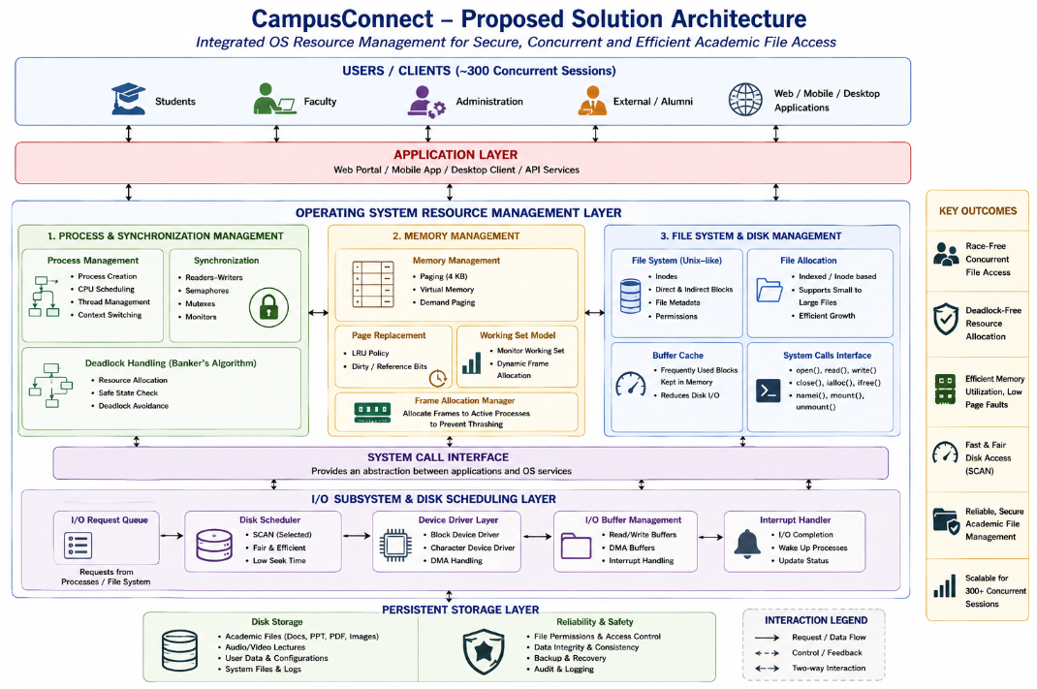

This integrated approach addresses the major synchronization, memory and file-system requirements of CampusConnect and aligns with the CSA04 syllabus topics and course outcomes.

9. Student Reflection
Through this project, I learned that Operating System concepts cannot always be considered independently. Process synchronization, memory management and file systems are interconnected.
For example, when a user accesses a shared file, the process-management subsystem controls synchronization, the memory-management subsystem determines how the file data is brought into memory, and the file system determines where the data is stored and how disk requests are handled.
I also understood that choosing an algorithm requires considering practical trade-offs rather than selecting the theoretically best algorithm. For example, Optimal page replacement produces the minimum number of page faults, but it cannot be directly implemented because future references are unknown. Similarly, FCFS is simple but can result in very large disk-head movement.
If additional time and resources were available, I would improve the project by:
- Testing with real CampusConnect workloads.
- Simulating more than 300 concurrent users.
- Comparing additional page-replacement algorithms.
- Implementing a complete Linux pthread application.
- Measuring actual execution time.
- Testing the system on SSD and HDD storage.
- Adding security and access-control mechanisms.
- Investigating distributed/network file systems.

10. References
Use IEEE style:
[1] A. Silberschatz, P. B. Galvin, and G. Gagne, Operating System Concepts, 10th ed. Hoboken, NJ, USA: John Wiley & Sons, 2018.
[2] M. J. Bach, The Design of the UNIX Operating System. Englewood Cliffs, NJ, USA: Prentice Hall.
[3] W. Stallings, Operating Systems: Internals and Design Principles, 9th ed. Upper Saddle River, NJ, USA: Prentice Hall, 2021.
[4] A. S. Tanenbaum, Modern Operating Systems, 5th ed. Addison-Wesley, 2022.
[5] D. M. Dhamdhere, Operating Systems: A Concept-Based Approach, 3rd ed. New Delhi, India: Tata McGraw-Hill Education, 2017.
[6] C. Crowley, Operating Systems: A Design-Oriented Approach. New Delhi, India: Tata McGraw-Hill, 2017.
These textbooks are the ones listed in the supplied CSA04 syllabus.

F. Common Assessment Rubric
Assessment Criterion | Marks
Problem understanding & formulation | 10
Application of course / domain knowledge (Scheduling, Paging, Disk) | 20
Solution methodology / design / implementation | 20
Use of appropriate modern tools / techniques (Streamlit, Python) | 10
Results, testing & validation | 15
Analysis, trade-offs & justification | 15
Broader considerations / professional responsibility | 5
Technical documentation & reflection | 5
TOTAL | 100

G. CO–PO–Assessment Mapping
Assessment Component | CO | PO(s) | Bloom's Level | Marks
Problem formulation | CO1/CO2 | PO1, PO2 | L3 | 10
Application – Process Scheduling | CO1/CO2 | PO1, PO2, PO3 | L3/L4 | 8
Application – Page Replacement | CO3 | PO1, PO2, PO3 | L3/L4 | 6
Application – Disk Scheduling | CO4 | PO1, PO2, PO3 | L3/L4 | 6
Solution / Design – Integrated OSLearn | CO1–CO4 | PO2, PO3, PO5 | L4/L5/L6 | 20
Modern tool usage (Streamlit / Python) | CO1–CO4 | PO5 | L3 | 10
Validation of results | CO1–CO4 | PO4 | L4/L5 | 15
Analysis & justification / trade-offs | CO1–CO4 | PO2, PO4 | L4/L5 | 15
Broader considerations & documentation / reflection | CO1–CO4 | PO6, PO12 | L3/L4 | 10
Note: PO numbers indicated are illustrative; faculty shall verify against the current CSA04 CO–PO matrix and map only the POs genuinely assessed.

H. Faculty Evaluation & Continuous Improvement

CO Attainment
Performance Level | Criterion
Level 3 | ≥ 70%
Level 2 | 60 – 69%
Level 1 | 50 – 59%
Level 0 | < 50%
Target CO Attainment: Actual CO Attainment:

Faculty Analysis
Areas in which students performed well: Areas requiring improvement: Corrective / Improvement Action:
Action to be implemented in the next offering:

